**IOT AND PLC BASED HOME AUTOMATION SYSTEM WITH PV INVERTER**

PROJECT REPORT

submitted by

**MATHEW VARGHESE**

Reg. No : **MAC15EC079**

**AMEER FAYIZ**

Reg. No : **MAC15EC017**

to

the APJ Abdul Kalam Technological University in partial fulfillment of the requirements for the award of the Degree

of

Bachelor of Technology in

*Electronics and Communication Engineering*



**Department of Electronics and Communication Engineering**

Mar Athanasius College of Engineering

Kothamangalam, Kerala, India 686 666

April 2019

**Department Of Electronics and Communication Engineering**

**Mar Athanasius College Of Engineering Kothamangalam**



**CERTIFICATE**

This is to certify that the report entitled **IOT AND PLC BASED HOME AUTOMATION SYSTEM WITH PV INVERTER** submitted by **Akash**

**S Kumar, Akhil M L, Ammu P, Vani S** to the APJ Abdul Kalam Technological

University in partial fulfillment of the requirements for the award of the Degree of Bachelor of Technology of Electrical & Electronics Engineering is a bonafide record of the project presented by us under our guidance and supervision. This report in any form has not been submitted to any other University or Institute for any purpose.

|  |  |
| --- | --- |
| **Prof. Leela Salim** | **Dr. Siny Paul** |
| Project Guide | Faculty Advisor |

**Prof. Acy M Kottalil** Head Of The Department

# ACKNOWLEDGEMENT

It is a great pleasure to acknowledge all those who have assisted and supported me for successfully completing my seminar.

First of all, I thank God Almighty for his blessings as it is only through his grace that I was able to complete my seminar successfully.

I take this opportunity to extend my sincere thanks to my seminar guide Prof. Leela Salim, Assistant Professor, Department of Electrical & Electronics Engineering for her constant support and immense contribution for the success of my seminar.

I also extend my sincere thanks to Faculty Advisor, Dr. Siny Paul, Associate Professor, Electrical & Electronics Engineering Department, and all other members of the Department of Electrical & Electronics Engineering for sharing their valuable comments during the preparation of the seminar.

I am also grateful to Prof. Acy M Kottalil, Head of Electrical & Electronics Engineering Department, for the valuable guidance as well as timely advice which helped me a lot during the preparation of the seminar.

I am deeply indebted to Dr. Solly George, Principal, Mar Athanasius College of Engineering for her encouragement and support.

I whole - heartedly thank all my classmates, for their valuable suggestions and for the spirit of healthy competition that existed between us.

**ABSTRACT**

Every electronic circuit is assumed to operate some supply voltage which is usually assumed to be in constant in nature. A voltage regulator is a power electronic circuit that maintains a constant output voltage irrespective of change in load current or line voltage. Many different types of voltage regulators with a variety of control schemes are used. With the increase in circuit complexity and improved technology a more severe requirement for accurate and fast regulation is desired. This has led to need for newer and more reliable design of DC-DC converters. It inputs an unregulated dc voltage input and outputs a constant or regulated voltage. DC-DC converters have been applied to industrial application widely during the past few decades. With rapid development of technology, negative output dc-dc converters play an important role in industrial fields such as regenarative braking system of DC motors for hybrid elelctric vehicles, signal generator, data transmission interface etc. In this project a new negative output buckboost converter, which can be applied for applications that need wide range of inverse voltage is proposed. This topology reverses the polarity of input voltage , but allows the absolute output voltage to be higher or lower than the absolute input voltage. Thus the proposed converter can provide a considerable alternative for industrial applications which need wide range of negative output voltage. All the simulation work are done in

MATLAB/SIMULINK software.

**Contents**

**Acknowledgement** **i**

**1 INTRODUCTION** **1**

**2 LITERATURE REVIEW** **3**

**CONVERSION RATIO** **5**

3.0.1 NEGATIVE OUTPUT BUCK-BOOST CONVERTER 5

3.1 OPERATING PRINCIPLE 6

3.1.1 First Stage 6

3.1.2 Second Stage 7

3.2 VOLTAGE CONVERSION RATIO 7

3.3 DESIGN 8

3.3.1 Design of Inductors 8

3.3.2 Design of Capacitors 9

**4 SIMULATION ANALYSIS** **10**

4.1 BOOST OPERATION 10

4.2 BUCK OPERATION 13

4.3 ANALYSIS AND RESULTS 14

**5 HARDWARE IMPLEMENTATION** **16**

5.1 BLOCK DIAGRAM 16

5.2 ARDUINO 17

5.2.1 General Pin Functions 17

5.3 DRIVER CIRCUIT 18

5.3.1 MOSFET Driver TLP250 19

5.4 MOSFET IRF540 20

**6 CONCLUSION** **22**

**3 NEGATIVE OUTPUT BUCK-BOOST CONVERTER WITH WIDE**

**LIST OF TABLES**

No. Title Page No.

4.1 Simulation Parameters for buck mode . . . . . . . . . . . . . . . . . . . 11

4.2 Simulation parameters for buck mode . . . . . . . . . . . . . . . . . . . 13

**LIST OF FIGURES**

No. Title Page No.

|  |  |
| --- | --- |
| 3.1 Circuit Diagram of Negative Output Buck-Boost Converter . . . . . . . | 6 |
| 3.2 First stage . . . . . . . . . . . . . . . . . . . . . . . . . . . . . . . . . . | 6 |
| 3.3 Second stage . . . . . . . . . . . . . . . . . . . . . . . . . . . . . . . . . | 7 |
| 3.4 Time Domain Waveforms of the Converter . . . . . . . . . . . . . . . . | 7 |
| 4.1 Simulink model . . . . . . . . . . . . . . . . . . . . . . . . . . . . . . . | 10 |
| 4.2 (a) Input Voltage(Vin) (b) Output Voltage(Vo) . . . . . . . . . . . . . | 11 |
| 4.3 (a) Gate Pulse1 (b) Switch Voltage . . . . . . . . . . . . . . . . . . . . | 12 |
| 4.4 (a) Gate Pulse2 (b) Switch Voltage . . . . . . . . . . . . . . . . . . . . | 12 |
| 4.5 (a)Inductor Current (L1) (b)Inductor Current (L2) . . . . . . . . . . . | 12 |
| 4.6 (a)Capacitor Voltage(Vc) (b)Capacitor Voltage (Vco) . . . . . . . . . . | 12 |
| 4.7 (a) Input Voltage (b)Output Voltage . . . . . . . . . . . . . . . . . . . | 13 |
| 4.8 (a)Gate Pulse1 (b)Switch Voltage . . . . . . . . . . . . . . . . . . . . . | 14 |
| 4.9 (a)Gate Pulse2 (b)Switch Voltage . . . . . . . . . . . . . . . . . . . . . | 14 |
| 4.10 (a)Inductor Current(L1) (b)Inductor Current(L2) . . . . . . . . . . . . | 14 |
| 4.11 (a)Capacitor Voltage(Vc) (b)Capacitor Voltage(Vco) . . . . . . . . . . | 15 |
| 4.12 Simulation analysis of Dutyratio verses Gain . . . . . . . . . . . . . . . | 15 |
| 4.13 Simulation Analysis of Dutyratio verses Switching Stress . . . . . . . . | 15 |
| 5.1 Block Diagram . . . . . . . . . . . . . . . . . . . . . . . . . . . . . . . | 16 |
| 5.2 Arduino UNO . . . . . . . . . . . . . . . . . . . . . . . . . . . . . . . . | 18 |
| 5.3 Pin Diagram of Arduino UNO . . . . . . . . . . . . . . . . . . . . . . . | 18 |
| 5.4 Gate Driver Circuit . . . . . . . . . . . . . . . . . . . . . . . . . . . . | 19 |
| 5.5 Diagram of TLP250 . . . . . . . . . . . . . . . . . . . . . . . . . . . . | 19 |
| 5.6 Pin diagram of TLP250 . . . . . . . . . . . . . . . . . . . . . . . . . . | 20 |
| 5.7 Image of IRF540 . . . . . . . . . . . . . . . . . . . . . . . . . . . . . . | 21 |

**CHAPTER 1**

# INTRODUCTION

Before the development of power semiconductors and allied technologies, one way to convert the voltage of a DC source to a higher voltage, for low power applications, was to convert it to AC by using vibrator, followed by a step up transformer and rectifier. For higher power an electric motor was used to drive a generator of the desired voltage. These are relatively inefficient and expensive procedures used only when there was no alternatives, as to power a car radio. The introduction of power semiconductors and integrated circuits made it economically viable to use these techniques.

Every Electronic circuit is assumed to operate some supply voltage which is usually assumed to be constant in nature. A voltage regulator is a power electronic circuit that maintains a constant output voltage irrespective of change in load current or line voltage. Many different types of voltage regulators with a variety of control schemes are used. With an increase in circuit complexity and improved technology a more severe requirement for accurate and fast regulation is desired. This has led to need for newer and more reliable design of dc-dc converters. The dc-dc converter inputs an unregulated dc voltage input and outputs a constant voltage.

With rapid development of technology, negative output (N/O) dc-dc converters play an important role in the industrial fields. The negative output converter is a modication of the buck-boost converter and provides inverse output voltage with wide conversion ratio. This new converter uses the energy-transferring capacitor to store energy, and there is no abruptly changing voltage on it. With rapid development of technology, negative output DC-DC converters play an important role in the industrial elds, such as regenerative braking system (RBS) of DC motors for hybrid electric vehicles, signal generator and data transmission interface, neutral point clamping power electronics systems, wind power generation and photovoltaic power generation etc.

The buck-boost converter and cuk converter are two typical traditional N/O converters, and their voltage conversion ratios are same. They can generate a higher or lower output voltage value than the input voltage. Theoretically, they both can produce an extremely high step down or step up output voltage when duty cycle D is close to 0 or 1. However, in practical operation, this situation cannot be met for the limitation of power switches and diodes. Additionally, a transformer can be used to get a larger conversion ratio, such as a flyback converters which also obtain negative output voltage. Unfortunately, the transformer causes switch voltage overshoot and EMI problems that lead to low efficiency and huge volume.

Electronic circuit designs often require power sources with negative output voltages. That means, we may often need a dual symmetric power sources, because when we deal with electrical signals, we always need a reference to express their variations. In buck-boost converter, the output voltage is of opposite polarity as that of the input voltage. This is a switched mode power supply with a similar circuit topology to the boost converter and the buck converter. The output voltage is adjustable based on the duty cycle. One possible drawback of the converter is that switch doesnot have a terminal at ground. This complicates the driving circuitry. However, this drawback is of no consequences if the power supply is isolated from the load circuit,for example, the supply is a battery. Because the supply and diode polarity can be reversed. When they are reversed, the switch can be on either the ground side or the supply side. Here, a negative output buck-boost converter which can be applied for applications that need wide range of inverse voltage is proposed.

**CHAPTER 2**

# LITERATURE REVIEW

F.L. Luo [1] explained about the voltage lift technique. The voltage lift technique is a popular method widely applied in electronic circuit design. Since the effect of parasitic elements limits the output voltage and power transfer efficiency of DC-DC converters, the voltage lift technique can lead to improvement of circuit characteristics. After long term research, this technique has been successfully applied for DC-DC converters. These converters perform positive to negative DC-DC voltage-increasing conversion with high power density, high efficiency and cheap topology in simple structure. They are different from other existing DC-DC step-up converters and possess many advantages, including a high output voltage with small ripples. Therefore, these converters will be widely used in computer peripheral equipment and industrial applications, especially for high output voltage projects.

M. Zhu [2] introduces a new step-up DC-DC converter that provides a negative-topositive voltage-conversion path for the negative dc-voltage source. Compared with the classical Cuk and buck-boost converters, the proposed converter increases the voltage boost ability significantly using the switched capacitor and self lift techniques. It is featured with single power switch operation, common ground, transformerless structure, and clear energy delivery process. Therefore the relative simple structure is beneficial to potential industrial applications. It also has the characteristics of high efficiency, smooth currents at both sides, and small ripples.

O. Abutbul [3] proposed for a steep step-up of the line voltage. It integrates a switched-capacitor (SC) circuit within a boost converter. An SC circuit can achieve any voltage ratio, allowing for a boost of the input voltage to high values. It is unregulated to allow for a very high efficiency. The boost stage has a regulation purpose. It can operate at a relatively low duty cycle, thus avoiding diode-reverse recovery problems. The new circuit is not a cascade interconnection of the two power stages; their operation is integrated. The simplicity and robustness of the solution, the possibility of getting higher voltage ratios than cascading boost converters, without using transformers with all their problems, and the good overall efficiency are the benefits of the converter.

Y. Tang [4] introduce a high step-up voltage gain active-network converter with switched capacitor technique. The voltage gain of traditional boost converter is limited due to the high current ripple, high voltage stress across active switch and diode, and low efficiency associated with large duty ratio operation. High voltage gain is required in applications, such as the renewable energy power systems with low input voltage. The converter can achieve high voltage gain without extremely high duty ratio. In addition, the voltage stress of the active switches and output diodes is low. Therefore, low voltage components can be adopted to reduce the conduction loss and cost.

D. Maksimovic [5] described DC-DC conversion applications that require a large range of input or output voltages, conventional PWM converter topology must operate at extremely low duty ratios, which limits the operation to lower switching frequencies because of the minimum on-time of the transistor switch. This is eliminated in a new class of single transistor PWM converters featuring voltage conversion ratios with quadratic dependence on duty ratio. K. I. Hwu [6] introduced a negative KY buck converter is presented herein along with its soft switching operation. This converter can transfer the positive output to the negative output. Above all, zero voltage switching (ZVS) and zero current switching (ZCS) are used to achieve soft switching operation. Besides, the input current is limited to some extent. A simple soft switching technique is applied to the negative-output KY buck converter, to improve its efficiency as well as to reduce the current spike in input.

From the above survey, the negative output buck-boost converter overcome the current spike problem in output and the converter has high gain compared to other negative output converter .

**CHAPTER 3**

**NEGATIVE OUTPUT BUCK-BOOST CONVERTER WITH WIDE CONVERSION**

## RATIO

### 3.0.1 NEGATIVE OUTPUT BUCK-BOOST CONVERTER

DC-DC converters have been applied to industrial applications widely during the past few decades. The negative output converter is a modification of the buck-boost converter and provides inverse output voltage with wide conversion ratio. This new converter uses the energy-transferring capacitor to store energy, and there is no abruptly changing voltage on it. With rapid development of technology, negative output DC-DC converters play an important role in the industrial fields, such as regenerative braking system (RBS) of DC motors for hybrid electric vehicles, signal generator and data transmission interface, neutral point clamping power electronics systems, wind power generation and photovoltaic power generation etc. We have taken few assumptions on the design part.

1. Circuit is operating in steady state.
2. All components are real.
3. Proposed converter operates in continuous conduction mode.
4. Switch is closed for DT and opened for (1-D)T

Power switches are turned on and off simultaneously, so that there are two operation stages. First stage is when the power switches are turned on and second stage is the turning off of both switches.

The new negative output converter consists of an input voltage Vin, two power switches S1 and S2, two diodes D1 and D2, two inductors L1 and L2, two capacitors C and C0, and one resistive load R. For steady-state theoretical analysis, it is assumed that all components are ideal and the proposed converter operates in CCM. The circuit diagram of the converter is shown in figure 3.1

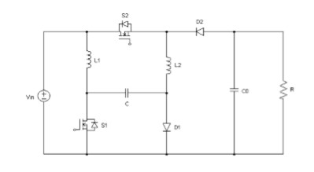

Figure 3.1: Circuit Diagram of Negative Output Buck-Boost Converter

## 3.1 OPERATING PRINCIPLE

Power switches are turned on and off simultaneously, so there are two operation stages. Currents through L1 and L2 are denoted by IL1 and IL2, respectively. The voltage across the capacitor C is defined as Vc, and the voltage across the output capacitor Co is defined as Vo.

### 3.1.1 First Stage

Power switches S1 and S2 are turned on during the subinterval (NT, NT+DT) in switching period, and diodes D1 and D2 are blocked via the reversal voltage. In this stage, the input voltage Vin supplies the energy to the inductor L1, and the capacitor C together with the input voltage Vin delivers the energy to the inductor L2. The voltage across the capacitor C is equal to the voltage stress on the diode D1. The difference value of the input voltage Vin and the output voltage Vo equals the voltage stress on the diode D2. The fitst stage operation is shown in figure 3.2

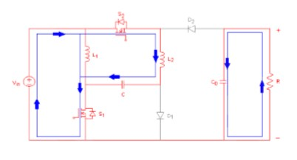

Figure 3.2: First stage

### 3.1.2 Second Stage

Power switches S1 and S2 are turned off during the subinterval (NT+DT, NT+T) in any switching period and diodes D1 and D2 conduct during this interval. Combining with the input voltage Vin, the inductor L1 supplies energy to the capacitor C through the diode D1. Meanwhile, the inductor L2 transfers energy to the output capacitor Co through the diodes D1 and D2. The voltage stress on the power switch S1 is equal to the voltage across the capacitor C, and the voltage stress on the power switch S2 equals Vin Vo. The stage two operation is shown in figure 3.3

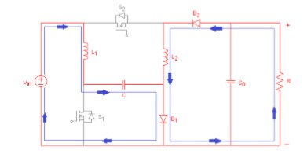

Figure 3.3: Second stage

Typical time domain waveforms of the proposed converter is shown in figure 3.4

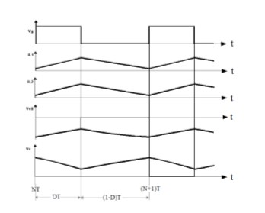

Figure 3.4: Time Domain Waveforms of the Converter

## 3.2 VOLTAGE CONVERSION RATIO

It is assumed that Vin, Vc, IL1, IL2, Io and Vo are corresponding DC values of Vin, Vc, IL1, IL2, Io and Vo. When the proposed converter is in steady state, inductors L1 and L2 satisfy the volt-second balance, that is, the net volt-seconds in one period is equal to zero.

|  |  |
| --- | --- |
| *DV in* + (1 − *D*)(*V in* − *V c*) = 0 | (3.1) |
| *D* (*V in* = *V c*) + (1 − *D*)*V o* = 0 | (3.2) |

Accordingly, Vc and Vo can be derived as

|  |  |
| --- | --- |
| *V c* = (*V in/*1 − *D*) | (3.3) |

 (3.4)

The voltage conversion ratio of the proposed converter is

 (3.5)

If the duty cycle is smaller than 0.29, the voltage conversion M is less than 1, that is the proposed converter works in step down mode. Otherwise, it works in step up mode.

## 3.3 DESIGN

For the design of components several assumptions are made. The input voltage is taken as 20V, output power is assumed to be 45W, output voltage is assumes as 35.6V. The pulses are switched at rate of 40kHz with a duty ratios of S1 and S2 are 0.4. The output load taken as 60. The switches and diodes are considered ideal.

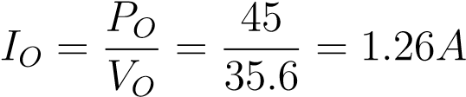 (3.6)

### 3.3.1 Design of Inductors

Current through the inductor L1

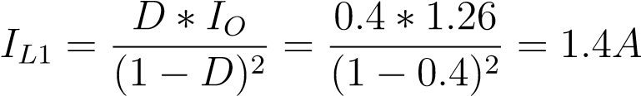 (3.7)

Assume current ripple 20% of inductor current L1

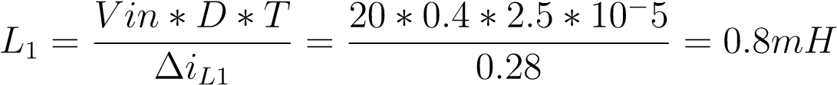 (3.8)

Current through the inductor L2

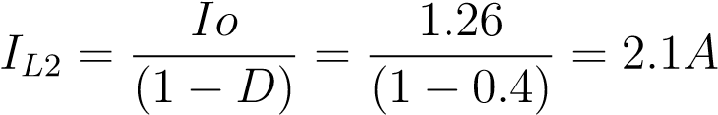 (3.9)

Assume current ripple 20% of inductor current L2

 (3.10)

### 3.3.2 Design of Capacitors

Voltage across the capacitors C

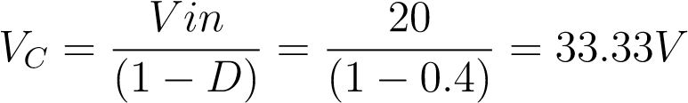 (3.11)

Assume a ripple 3% of capacitor voltage Vc



Voltage across the Capacitor Co

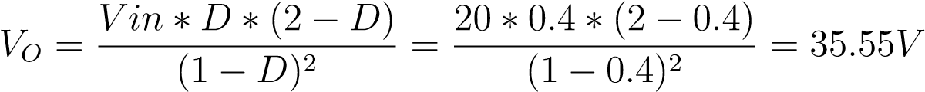 (3.13)

Assume voltage ripple 4% of capacitor voltage Vo



**CHAPTER 4**

# SIMULATION ANALYSIS

Simulation of the proposed converter is done with the help of MATLAB/Simulink. The simulation parameters, simulink model and results are shown below.

## 4.1 BOOST OPERATION

In step up mode(Boost Converter), output voltage is greater than the input voltage. It follows that the output current is less than the input current. To reduce voltage ripple, filters made of capacitors(sometimes in combination with inductors) are normally added to such a conveters output(load side filter) and input(supply side filter). The negative output output buck-boost converter shown in figure 3.1 is simulated in MATLAB/Simulink is shown in figure 4.1

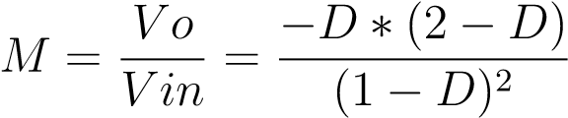 (4.1)

From the above equation M greater than 1 and dutyratio greater than 0.29, it can be operated as step up mode.

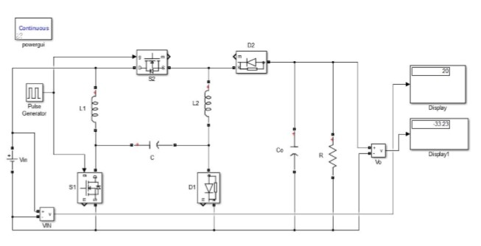

Figure 4.1: Simulink model

10

Key principles that drives the step up converter is the tendancy of an inductor to resist changes in current by creating and destroying magnetic field.

1. When the switch is closed current flows through inductor in clockwise direction and the inductor stores some energy by generating a magnetic field.
2. When the switch is opened currrent will be reduced as the impedence is higher.

The magnetic field previously created will be destroyed to maintain the current.

The description about the simulation parameters is given in the table.

|  |  |
| --- | --- |
| Input Voltage | 20 V |
| Output Voltage | - 35.6 V |
| Switching frequency | 40 KHz |
| Output load | 60 Ohm |
| Duty cycle | 0.4 |
| Inductor L1 | 0.8 mH |
| Inductor L2 | 1 mH |
| Capacitor C | 10 microF |
| Capacitor C0 | 44 microF |

Table 4.1: Simulation Parameters for buck mode

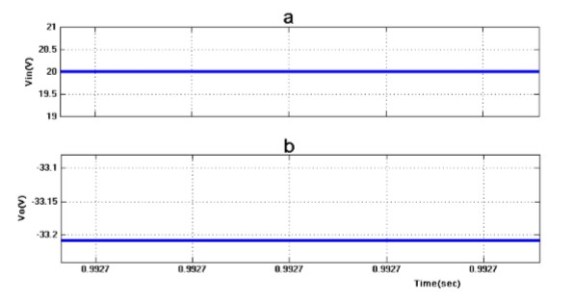

Figure 4.2: (a) Input Voltage(Vin) (b) Output Voltage(Vo)

From figure 4.2 it is clear that the the input voltage is 20V and the output voltage is -33.23V. Here the output voltages are greater than the input voltage so it can be used for boost operation.

Gate pulses of S1 are shown in Figure 5.3. Duty ratio of S1 is 0.4 and Voltage across S1 is 34V. Gate pulses of S2 are shown in Figure 4.4. Duty ratio of S2 is 0.4 and Voltage across S2 is 54V. Inductor current L1 and L2 are shown in figure 4.5. Inductor current of L1 is 0.8A and L2 is 1.2A. Capacitor voltages Vc and Vco are shown in figure 4.6.The capacitor voltages of Vc is 32.9V, and Vc is -33.23V .

Different simulation results of the proposed converter can be found out easily using the Matlab Software.

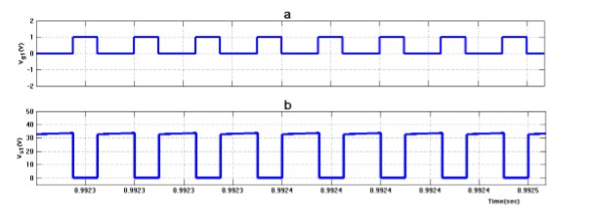

Figure 4.3: (a) Gate Pulse1 (b) Switch Voltage

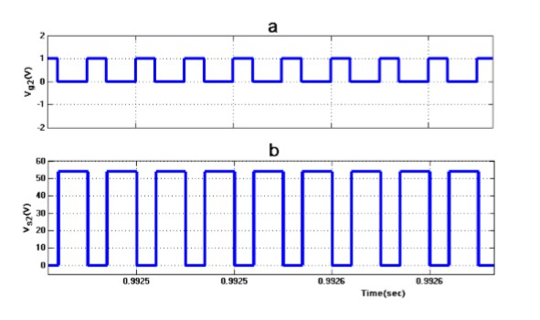

Figure 4.4: (a) Gate Pulse2 (b) Switch Voltage

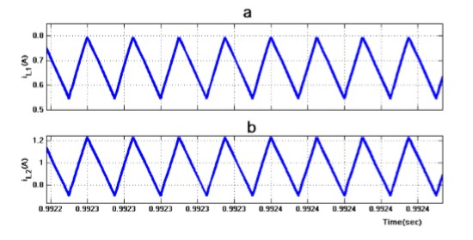

Figure 4.5: (a)Inductor Current (L1) (b)Inductor Current (L2)

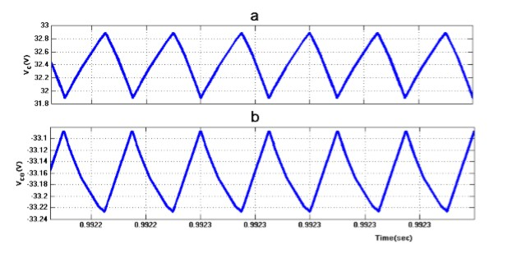

Figure 4.6: (a)Capacitor Voltage(Vc) (b)Capacitor Voltage (Vco)

## 4.2 BUCK OPERATION

In step down mode, output voltage is less than the input voltage. It follows that the output current is greater than the input current. It can be explained with the following equation.

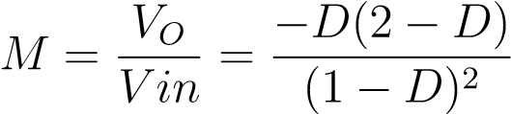 (4.2)

From the equation Mless thsn 1 and duty ratio is less than 0.29 it can be operated as step down mode. Values of different components can be calculated and are used in the

|  |  |
| --- | --- |
| Input Voltage | 20 V |
| Output Voltage | - 13.6 V |
| Switching frequency | 40 KHz |
| Output load | 60 Ohm |
| Duty cycle | 0.23 |
| Inductor L1 | 0.8 mH |
| Inductor L2 | 1 mH |
| Capacitor C | 10 microF |
| Capacitor Co | 44 microF |

Table 4.2: Simulation parameters for buck mode

simulation process.

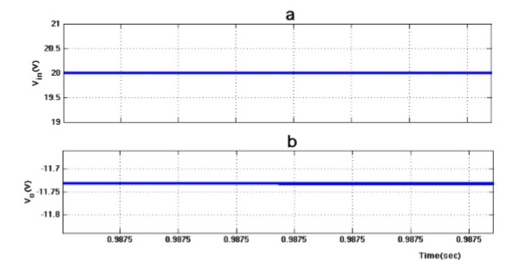

Figure 4.7: (a) Input Voltage (b)Output Voltage

From the Figure 5.7 it is clear that the input voltage is 20V and the output voltage is -11.72V. Here the output voltages are less than the input voltage so it can be used for buck operation.

Gate pulses of S1 are shown in figure 5.8. Duty ratio of S1 is 0.23 and voltage across S1 is 27V. These are the different waveforms obtained from the Matlab Software while doing the simulation. The basic operation of step down converter is the current in an inductor controlled by two switches. In idealized converter all the components

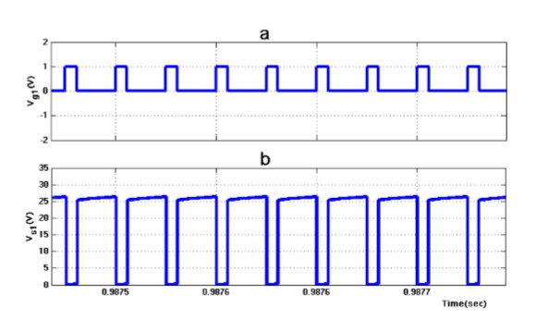

Figure 4.8: (a)Gate Pulse1 (b)Switch Voltage

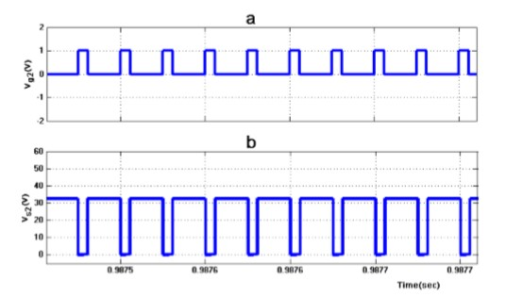

Figure 4.9: (a)Gate Pulse2 (b)Switch Voltage

are perfect. Specifically, the switch and diode have zero voltage drop when ON and zero current flow when OFF. Inductor current L1 and L2 are shown in figure 4.9. The

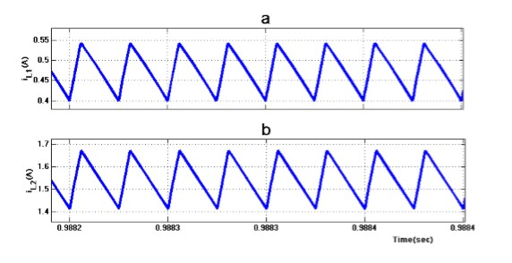

Figure 4.10: (a)Inductor Current(L1) (b)Inductor Current(L2)

inductor current of L1 is 0.55A and L2 is 1.7A. Capacitor voltages Vc and Vco are shown in figure 4.10. The capacitor voltages of Vc is 25.5V and Vco is -11.73V

## 4.3 ANALYSIS AND RESULTS

The negative output buck-boost converter has been simulated. All the analysis are done by varying the duty ratio. The converter has been operated in buck and boost mode

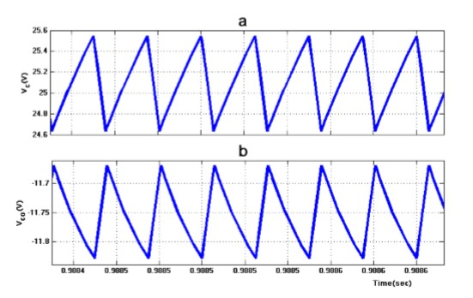

Figure 4.11: (a)Capacitor Voltage(Vc) (b)Capacitor Voltage(Vco)

by varying the duty ratio. From figure 4.11 it is clear that the graph plot dutyratio verses gain. Here we are consider dierent type negative output converter. As compare to other negative output converter the gain of the new negative output buck-boost converter is high .

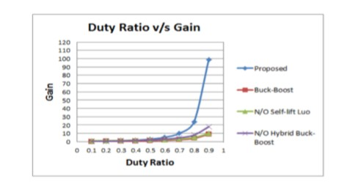

Figure 4.12: Simulation analysis of Dutyratio verses Gain

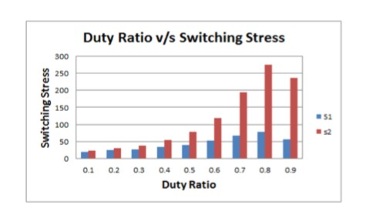

Figure 4.13: Simulation Analysis of Dutyratio verses Switching Stress

From the figure it is clear that the graph plot dutyratio verses switching stress. If the switching stress of S2 is higher than that of S1. The maximum switching stress is obtained at D=0.8 .

**CHAPTER 5**

# HARDWARE IMPLEMENTATION

Negative output buck-boost converters can be implemented using 2 inductors, 2 capacitors, 2 diodes and 2 Mosfet switches.

## 5.1 BLOCK DIAGRAM

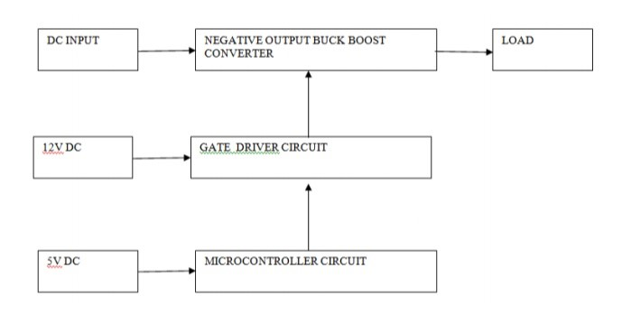

Figure 5.1: Block Diagram

The circuit consists of three parts-main circuit, gate driver circuit, and the microcontroller circuit. The gate pulse to the Mosfet in the main circuit is given by the gate driver circuit. We are using the gate driver TLP250. The pulse to the gate driver circuit is given by microcontroller circuit. The microcontroller circuit we used is an Arduino.

1. Arduino
2. Driver circuit
3. Mosfet IRF540

16

1. Mosfet driver TLP250

## 5.2 ARDUINO

The Arduino UNO is an open-source microcontroller board based on the Microchip ATmega328P microcontroller and developed by Arduino.cc. The board is equipped with sets of digital and analog input/output (I/O) pins that may be interfaced to various expansion boards (shields) and other circuits. The board has 14 Digital pins, 6 Analog pins, and programmable with the Arduino IDE (Integrated Development Environment) via a type B USB cable. It can be powered by a USB cable or by an external 9 volt battery, though it accepts voltages between 7 and 20 volts. The Uno board and version 1.0 of Arduino Software (IDE) were the reference versions of Arduino, now evolved to newer releases. The Uno board is the first in a series of USB Arduino boards, and the reference model for the Arduino platform. The ATmega328 on the Arduino Uno comes preprogrammed with a bootloader that allows uploading new code to it without the use of an external hardware programmer. It communicates using the original STK500 protocol. The Uno also differs from all preceding boards in that it does not use the FTDI USB-to-serial driver chip. Instead, it uses the Atmega16U2 (Atmega8U2 up to version R2) programmed as a USB-to-serial converter.

### 5.2.1 General Pin Functions

1. LED: There is a built-in LED driven by digital pin 13. When the pin is HIGH value, the LED is on, when the pin is LOW, it’s off.
2. VIN: The input voltage to the Arduino/Genuino board when it’s using an external power source (as opposed to 5 volts from the USB connection or other regulated power source). You can supply voltage through this pin, or, if supplying voltage via the power jack, access it through this pin.
3. 5V: This pin outputs a regulated 5V from the regulator on the board. The board can be supplied with power either from the DC power jack (7 - 20V), the USB connector (5V), or the VIN pin of the board (7-20V). Supplying voltage via the 5V or 3.3V pins bypasses the regulator, and can damage the board.
4. 3V3: A 3.3 volt supply generated by the on-board regulator. Maximum current draw is 50 mA.
5. GND: Ground pins.
6. IOREF: This pin on the Arduino/Genuino board provides the voltage reference with which the microcontroller operates. A properly configured shield can read the IOREF pin voltage and select the appropriate power source or enable voltage translators on the outputs to work with the 5V or 3.3V.
7. Reset: Typically used to add a reset button to shields which block the one on the board.

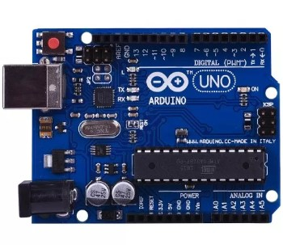

Figure 5.2: Arduino UNO

Figure shows an arduino microcontroller.

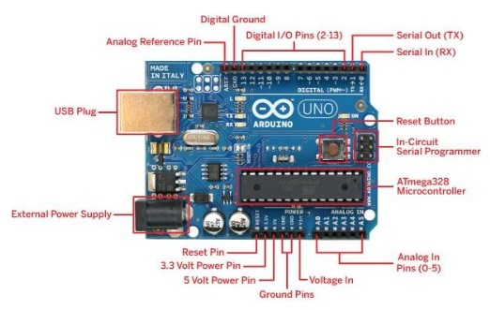

Figure 5.3: Pin Diagram of Arduino UNO

This is the pin diagram of an Arduino UNO.

## 5.3 DRIVER CIRCUIT

TLP250 is used as the Mosfet driver. Figure 5.4 shows the gate driver circuit. Pulses from the arduino is given to the Mosfet driver TLP250. The output from the driver circuit is given to the Mosfet gate in the main circuit. +12 V DC supply is given to the driver circuit.

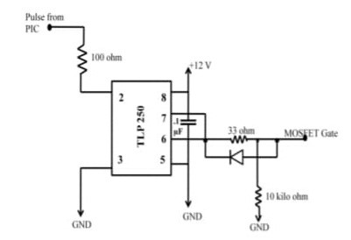

Figure 5.4: Gate Driver Circuit

### 5.3.1 MOSFET Driver TLP250

The driver TL250 like other MOSFET drivers have input stage and output stage. It also have power supply configuration. TLP250 is more suitable for MOSFET and IGBT. Here, IRF540 Mosfet is uesd. The main difference between TLP250 and other MOSFET drivers is that TLP250 MOSFET driver is optically isolated. Its mean input and output of TLP250 mosfet driver is isolated from each other. Its works like a optocoupler. Input stage have a light emitting diode and output stage have photo diode. Whenever input stage LED light falls on output stage photo detector diode, output becomes high. Image of TLP250 is shown in figure 5.5

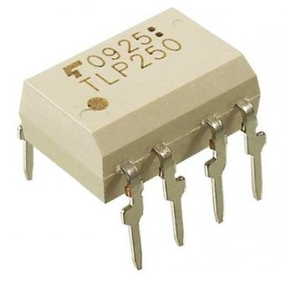

Figure 5.5: Diagram of TLP250

Pin layout of TLP250 is shown in figure 5.6. It is clearly shown in figure that led at input stage and photo detector diode at output stage is used to provide isolation between input and ouput. Pin number 1 and 4 are not connected to any point. Hence they are not in use. Pin 2 is anode point of input stage light emitting diode and pin 3 is cathode point of input stage. Input is provided to pin number 2 and 3. Pin number 8 is for supply connection. Pin number 5 is for ground of power supply.

1. Pin number one and four is not connected to any point physically. Therefore they are not in use.

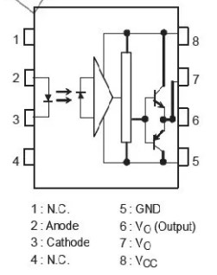

Figure 5.6: Pin diagram of TLP250

1. Pin number 8 is use to provide power supply to TLP250 and pin number 5 is ground pin which provides return path to power supply ground.
2. Pin number 2 and 3 are anode and cathode points of input stage LED. It works like a normal light emitting diode. It has similar characteristics of forward voltage and input current.
3. Pin number six and seven is internally connected to each other. Ouput can be taken from either pin number 6 and 7. Totem pole configuration of two transistor is used in TLP250. In case of high input , output becomes high with output voltage equal to supply voltage and in case of low input, output become low with output voltage level equal to ground.

## 5.4 MOSFET IRF540

IRF540 is basically an N-Channel power Metal Oxide Silicon Field Effect Transistor (MOSFET) and operates in enhancement mode. Mosfet is a lot sensitive in comparison to an FET (Field Effect Transistor) due to its very high input impdence. IRF540 can perform very fast switching as compared to the normal transistor. If we need some switching application between different signals or to perform any of amplification process, MOSFET IRF540 will be the best option in this case because it can perform very fast switching as compared to the similar general transistors. It has a very wide range of applications in real life e.g. high power switching drivers for high speed, switching regulators, relay drivers, switching converters, motor drivers. Figure shows the image of IRF540.

IRF540 works on a pretty simple principle. Its has three kinds of terminals e.g. Drain, Gate and Source. When we apply any of the pulse at its Gate terminal, its Gate and Drain gets short i.e. they make a common connection with each other. When the Gate and the Drain gets short, only then we will be able to obtain the desired results otherwise it will produce unnecessary or unwanted results.

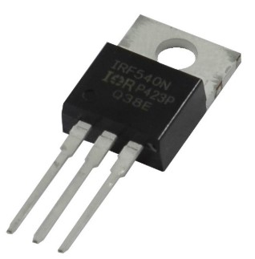

Figure 5.7: Image of IRF540

**CHAPTER 6**

# CONCLUSION

The negative output buck-boost converter has a wide range of applications including in high power conversion applications,regenerative braking of DC motors in hybrid elecric vehicles. The main advantage of the proposed converter is that it has no current spikes. Also it can achieve a wider range of negative output voltage. As compared to other negative output converter the gain of the converter is also high. Thus, it can be a considerable alternative for industrial applications which need wide range of negative output voltage.

22

**REFERENCES**

1. Shumin Ding, Faqiang Wang, New Negative output buck-boost converter with wide conversion ratio, IEEE transactions on industrial electronics
2. F.L. Luo, Negative output Luo converters: voltage lift technique, IEE Pioc. Electr. Power Appl., vo1. 146, no. 2, pp. 208-224, Mar. 1999.
3. M. Zhu and F. L. Luo, Enhanced self-lift Cuk converter for negative-to-positive voltage conversion, IEEE Trans. on Power Electron., vol. 25, no. 9, pp. 2227-2233, Sep. 2010.
4. O. Abutbul, A. Gherlitz, Y. Berkovich, and A. Ioinovici, Step-up switchingmode converter with high voltage gain using a switched capacitor circuit, IEEE Transaction Circuits SystemsI, Fundamental Theory Application , vol. 50, no. 8, pp. 10981102, August 2003
5. K. I. Hwu, Y. T. Yau and Z. F. Lin, Negative-output KY buck-boost converter, in Proc. IEEE Industrial Electronics and Applications Conf., May 2009
6. K. I. Hwu, W. C. Tu and Y. H. Chen, A novel negative-output KY boost converter, in Proc. IEEE Power Electronics and Drive Systems Conf., Nov. 2009
7. D. Maksimovic and S. Cuk, Switching converters with wide DC conversion range, APEC 2001. IEEE Transactions on Power Electronics , vol. 6, no. 1, pp. 151-157, January 1991.
8. K. I. Hwu, Y. T. Yau and J. J. Shieh, Negative-Output Resonant Voltage Divider, Proceeding IEEE Power Electronics and Driver Systems Conference, December 2011, pp. 935 939.

23